**DTMF Controlled Metal Detector Robotic Vehicle**

**using Metal Detector Circuit and Arduino**

**Abstract**: This paper describes the implementation of DTMF controlled Robotic vehicle with metal detection using Arduino. The proposed system consists of Arduino and a metal detector circuit. The Arduino is interfaced with DTMF to operate the robot. The DTMF receives these commands and moves the robot according to the received commands. A metal detector is interfaced to the robot. The metallic objects are detected by simple Thus, whenever any metallic object is detected buzzer starts ringing.

**1.Introduction:**

Land mines buried under the ground causes threat to the lives and affect the economy of the nation. Detection and removing of these mines manually is a difficult task, which may causes injuries. In such a situation robots aid in detection of the land mines. Other than land mines, these robots can be used to detect any other metals present in the ground.

Movement of metal detector robot is controlled by cell phone. Metal is detected with the help of metal detector circuit and buzzer starts ringing when it detects metallic object. Two Arduino boards are required, one to control the movement of robot and other to detect metallic objects. This device can be used to detect the presence of metal in its close proximity without physically touching it

**2. System Description:**

The objective of the work is to develop prototype robot which detects metallic (ferromagnetic) objects. Two DC geared motors are used for controlling the movement of the robot. Whenever metal is detected, the robot stops its movement whereas buzzer starts ringing. After few seconds, the robot then deviates around the object and

Continues scanning of the area. The obstacles are detected by Ultrasonic sensor. The entire system’s operation can be controlled using Arduino Uno or ATmega2560 microcontroller.

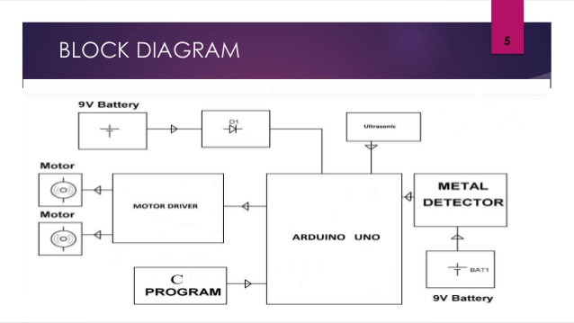

**Figure 1:** System block diagram

The Block diagram of the system is shown in Figure 1. Four port bits of microcontroller are used to control the soft keys and command keys of cell phone. Ultrasonic sensor module is used to detect obstacles in left, right and front regions of the robot. Metal Detector circuit is used to detect metallic objects.

The microcontroller controls the selection of DC motors through L293D driver IC and direction of movement of robot depends on motor's state. If both

motors are in ON states, the robot moves straight in forward or reverse direction depending on connections. However, if only one motor is ON, then robot takes right or left turn depending on position of motor currently in ON state.

**2.1 Metal Detector Circuit:**

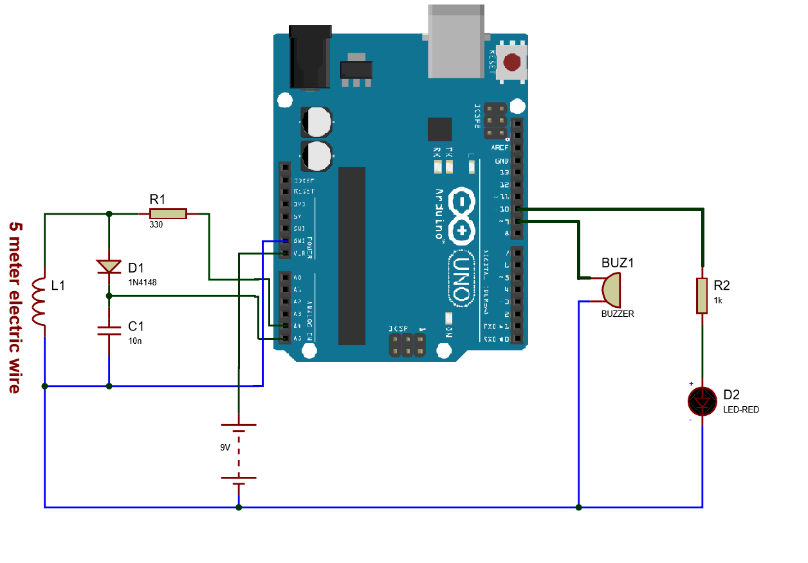**Figure 2:** Metal detector circuit

Working Concept:

Whenever some current passes through the coil, it generates a magnetic field around it. And the change in the magnetic field generates an electric field. Now according to Faraday's law, because of this Electric field, a voltage develops across the coil which opposes the change in magnetic field and that’s how Coil develops the Inductance, means the generated voltage opposes the increase in the current. When sensing coil is brought near a metallic object, magnetic energy is absorbed. As a result, buzzer is activated. The coil is externally mounted at front end of robot prototype to detect metallic obstacles.

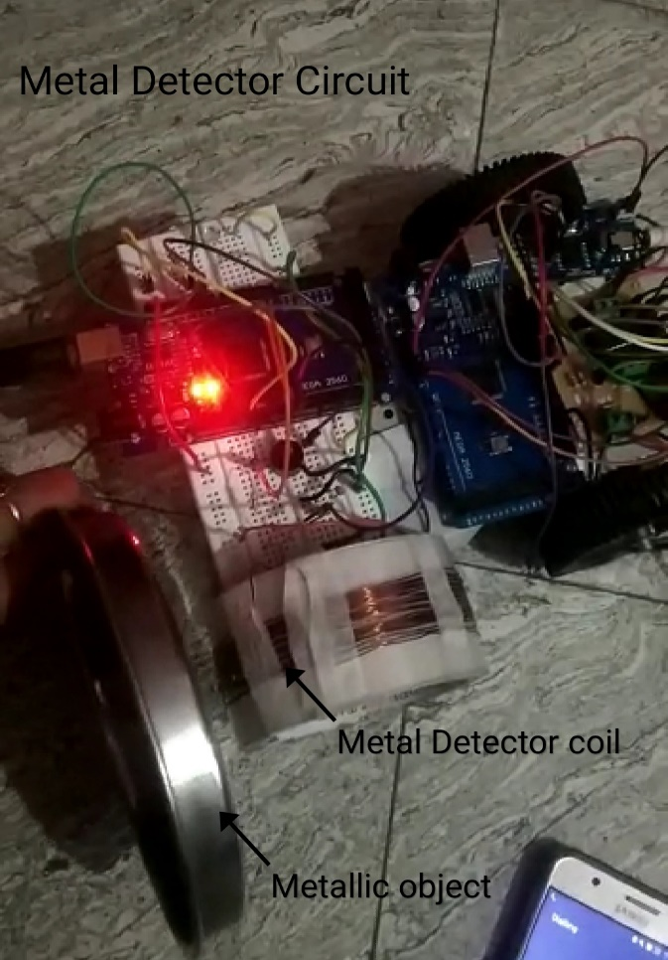

**Figure 3:** Front-end-view of robot prototype

**2.2 Ultrasonic Sensor Module:**

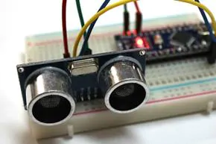

**Figure 4:** Ultrasonic sensor

Ultrasonic sensors work very similar to the technology that nature evolved for bats. The sound is just outside of the range of human hearing and is directed away from the emitter.

When the sound bounces off something in the path it returns to the sensor. Since we know the speed of sound, it’s easy to calculate the distance.

It has got four pins. They are:

(a). Vcc: The Vcc pin powers the sensor, connected with +5V of Arduino Board.

(b). Trigger: It is an input pin. This pin has to be kept high for 10us to initialize measurement by sending ultrasonic wave. The code snippet: digitalWrite (trigPin, HIGH); delay Microseconds (10); digitalWrite (trigPin, LOW).

(c). Echo: Its pin is an output pin. This pin goes high for a period of time which will be equal to the time taken for the ultrasonic wave to return back to the sensor. The code snippet: duration = pulseIn (echoPin, HIGH);

(d). Ground: This pin is connected to the Ground of the Arduino Board.

**2.3 Mechanical Aspects:**

The chassis of robot provides support for motors, batteries, sensors, circuit, cell phone and the controller. The board of

10 × 18 cm dimensions was chosen (fig 5). Two gear head DC motors of 12V, 150 rpm are attached at the bottom of the board using clampers. The front wheel consists of a small iron ball rotating on sliding arrangement. The two side wheels are chosen of 6 cm diameter and thickness of 2 cm. These side wheels are mechanically coupled to DC motor shaft through gear assembly to improve the torque.

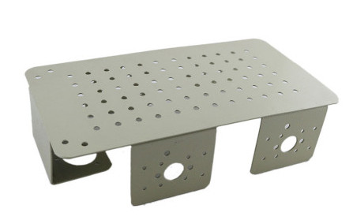

**Figure 5:** Metal Chassis

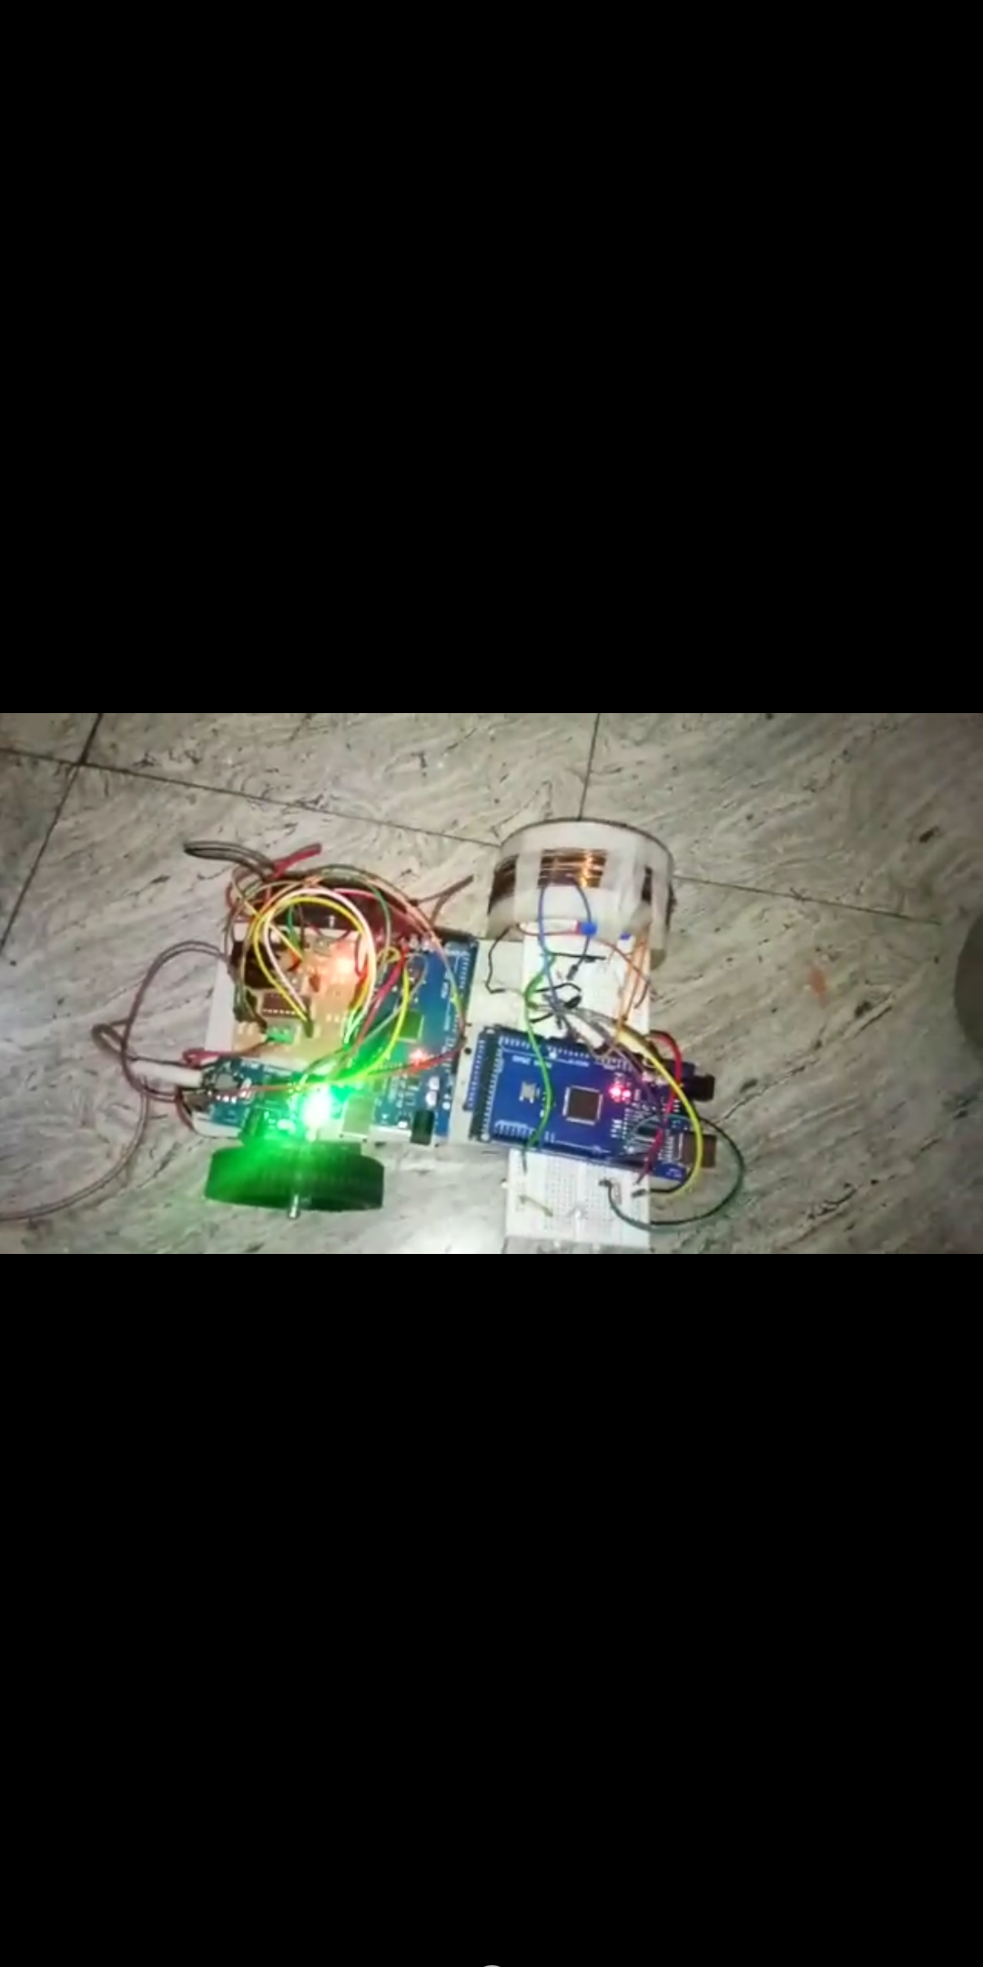

**Figure 6:** Top-view of robot prototype

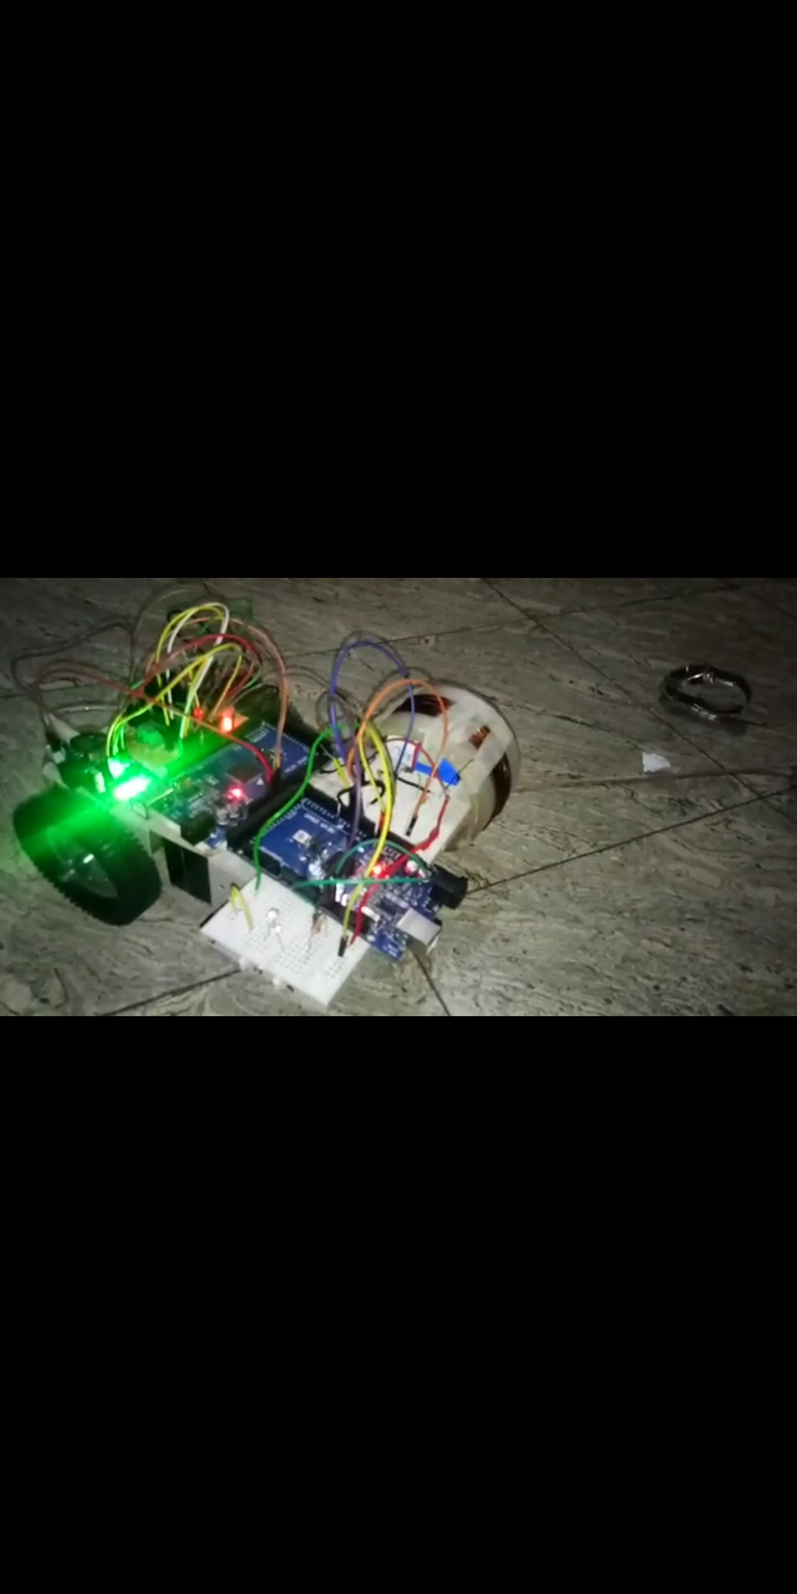

**Figure 7:** Left-side-view of robot prototype

**3. Microcontroller System:**

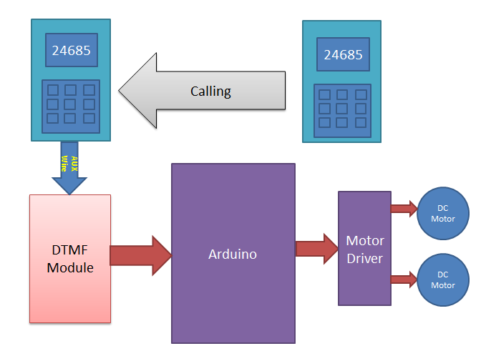

Block diagram of DTMF controlled Arduino based Robot

**Remote section:** This section’s main component is DTMF. Here we get a tone from our cellphone by using aux wire to DTMF Decoder IC namely MT8870 which decodes the tone into digital signal of 4bit.

**Control Section:** Arduino UNO is used for controlling whole the process of robot. Arduino reads commands sent by DTMF Decoder and compare with define code or pattern. If commands are match Arduino sends respective command to driver section.

**Driver section:** driver section consists motor driver and two DC motors. Motor driver is used for driving motors because Arduino does not supply enough voltage and current to motor. So, we add a motor driver circuit to get enough voltage and current for motor. By collecting commands from Arduino motor driver drive motor according to commands.

Working of DTMF Controlled Robot: Run by some commands that are send via mobile phone. We are using DTMF function of mobile phone. Here we have used the mobile phone to show the working of project. One is user mobile phone called as ‘remote phone’ and second one is connected to DTMF using aux cable. This mobile phone is called as ‘Receiver Phone’. First, we will make a call by using remote phone to receiver phone and then attend the call by manually or automatic answer mode.

Table 1: Coding for control keys of cell phone

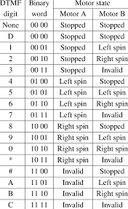

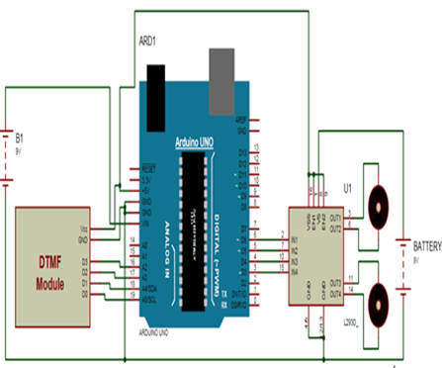

**Figure 8:** Circuit diagram of DTMF controlled Arduino based robot

**3.1 Metal detector circuit working explanation:**

Wave or pulse, generated by Arduino, to the LR high pass filter. Due to this, short spikes will be generated by the coil in every transition. The pulse length of the generated spikes is proportional to the inductance of the coil. So, with the help of these Spike pulses we can measure the inductance of Coil. But here it is difficult to measure inductance precisely with that spikes because that spikes are of very short duration (approx. 0.5 microseconds) and that is very difficult to be measured by Arduino.

So instead of this, capacitor which is charged by the rising pulse or spike is used. And it required few pulses to charge the capacitor to the point where its voltage can be read by Arduino analog pin A5. Then Arduino read the voltage of this capacitor by using ADC. After reading voltage, capacitor quickly discharged by making capPin as output and setting it to low. This whole process takes around 200 microseconds to complete. For better result, we repeat measurement and took an average of the results. That’s how the approximate inductance of Coil is measured. After getting the result it is transferred to the LED and buzzer to detect the presence of metal.

**4. Conclusions and Further Recommendations:**

Thus, robot prototype has been developed for metal detection. This system is able to detect metallic objects without human presence and informs user whenever metal is detected. The usage of cellular networks reduces the cost of establishment of wireless network and removes the constraints of range of the system. Any obsolete or unused cell phone model can work as system cell phone. The metal detector robot can be used to find the landmine when the robot moves on the earth. The main aim of this project is to sense and remove the landmines and also metals ahead of it in a short span of time. Further, this system can be enhanced by mounting a wireless camera on the robot, and the operator can control the robot’s movement simply by imaging it on a screen.

**5. Advantages of metal detector robot:**

DTMF is feasible and would be advantageous over the RF; it increases the range of working and also gives good results in case of motion and direction of robot using mobile phone through micro controller. This type of wireless communication gives the remote handling operation of Robot using DTMF.

**6. References:**

[1] Vasif Ahmed, N. P. Jawarkar and R. D Thakare, “Remote world-wide control through SMS using Nokia Mobile,” IETE Journal of Education, Vol 46, No. 4, Oct-Dec 2005, 165-170, 2005.

[2] Y. H. Lin, I. C. Jan, P. C. Ko, Y. Y. Chen, J. M. Wong and G. J Jan, “A wireless PDA-based physiological monitoring system for patient transport”. IEEE Transactions on Information Technology in Biomedicine, vol 8 No. 4, 439-447, 2004.

[3] G. K. Singh, V. M. Pendse, S. J. Sharma and S. Rajagopalan, “Ultrasonic velocity measurements using GSM Network”. Journal of Instrument Society of India, vol 39 No. 4, 258-59, 2009.

[4] Vasif Ahmed and S. A. Ladhake, “Design of ultra-low-cost cell phone based embedded system for irrigation” Journal of Instrument Society of India, vol 40 No. 2, 101-102, 2010.

[5]. DTMF Controlled Arduino Robot by Mr. R Suresh

[6]. Smart phone-based robot control for localization by Nik Firdaus bin Nik Mahmod

[7] Nokia C1-01 Device Technical specifications. Available: <http://www.developer.nokia.com/device>.

[8] Richard Barnett, Larry O‟Cull and Sarah Cox, Embedded C Programming and Atmel AVR, DelmarCengage Learning India Pvt. Ltd., 2007 Edition (India).

[9] Ponyprog software. Available: <http://www.lancos.com/>

[10] Vasif Ahmed and S. A. Ladhake, “Design of Microcontroller System with Cell Phone as remote-control console using Bluetooth and Java ME”, Journal of Instrument Society of India, Vol 41 No.1, 13-15, 2011.